## Jasmine & Karma

We can test our Angular applications from scratch by writing and executing pure javascript functions. Creating instances of the relevant classes, calling functions and checking the actual versus expected result.

But since testing is such a common activity with javascript there are a number of testing libraries and frameworks we can use which reduce the amount of time it takes to write tests.

Two such tools and frameworks that are used when testing Angular is *Jasmine* and *Karma* and a discussion of those is the topic of this lecture.

**Learning Objectives**

* What is the Jasmine test framework?
* How to write tests in Jasmine?
* What is the Karma test runner?
* How to create and run tests using the Angular CLI?
* How to create and run tests in Plunker?

**Jasmine**

Jasmine is a javascript testing framework that supports a software development practice called [Behaviour Driven Development](https://en.wikipedia.org/wiki/Behavior-driven_development), or BDD for short. It’s a specific flavour of [Test Driven Development](https://en.wikipedia.org/wiki/Test-driven_development) (TDD).

Jasmine, and BDD in general, attempts to describe tests in a human readable format so that nontechnical people can understand what is being tested. However even if you *are* technical reading tests in BDD format makes it a lot easier to understand what’s going on.

For example if we wanted to test this function:

function helloWorld() {

return 'Hello world!';

}

We would write a jasmine test

*spec*

like so:

describe('Hello world', () => {

①

it('says hello', () => {

②

expect(helloWorld())

③

.toEqual('Hello world!');

④

});

})

;

1. The describe(string, function) function defines what we call a *Test Suite*, a collection of individual *Test Specs*.
2. The it(string, function) function defines an individual *Test Spec*, this contains one or more *Test Expectations*.
3. The expect(actual) expression is what we call an *Expectation*. In conjunction with a *Matcher* it describes an *expected* piece of behaviour in the application.
4. The matcher(expected) expression is what we call a *Matcher*. It does a boolean comparison with the expected value passed in vs. the actual value passed to the expect function, if they are false the *spec* fails.

### Built-in matchers

Jasmine comes with a few pre-built matchers like so:

expect(array).toContain(member); expect(fn).toThrow(string); expect(fn).toThrowError(string); expect(instance).toBe(instance); expect(mixed).toBeDefined(); expect(mixed).toBeFalsy(); expect(mixed).toBeNull(); expect(mixed).toBeTruthy(); expect(mixed).toBeUndefined(); expect(mixed).toEqual(mixed); expect(mixed).toMatch(pattern);

expect(number).toBeCloseTo(number, decimalPlaces);

expect(number).toBeGreaterThan(number); expect(number).toBeLessThan(number);

expect(number).toBeNaN(); expect(spy).toHaveBeenCalled(); expect(spy).toHaveBeenCalledTimes(number); expect(spy).toHaveBeenCalledWith(...arguments);

You can see concrete examples of how these matchers are used by looking at the Jasmine docs here: <http://jasmine.github.io/edge/introduction.html#section-Included_Matchers>

### Setup and teardown

Sometimes in order to test a feature we need to perform some setup, perhaps it’s creating some test objects. Also we may need to perform some cleanup activities after we have finished testing, perhaps we need to delete some files from the hard drive.

These activities are called *setup* and *teardown* (for cleaning up) and Jasmine has a few functions we can use to make this easier:

**beforeAll**

This function is called **once**, *before* all the specs in describe test suite are run.

**afterAll**

This function is called **once** *after* all the specs in a test suite are finished.

**beforeEach**

This function is called *before* **each** test specification, it function, has been run.

**afterEach**

This function is called *after* **each** test specification has been run.

We might use these functions like so:

describe('Hello world', () => {

let expected = "";

beforeEach(() => {

expected = "Hello World";

});

afterEach(() => {

expected = "";

});

it('says hello', () => {

expect(helloWorld())

.toEqual(expected);

});

})

;

### Running Jasmine tests

To manually run Jasmine tests we would create a HTML file and include the required jasmine javascript and css files like so:

<link rel="stylesheet" href="jasmine.css">

<script src="jasmine.js"></script>

<script src="jasmine-html.js"></script>

<script src="boot.js"></script>

We then load in the parts of our application code that we want to test, for example if our *hello world* function was in main.js:

<

link rel="stylesheet" href="jasmine.css"

>

<

script src="jasmine.js"></script

>

<

script src="jasmine-html.js"></script

>

<

script src="boot.js"></script

>

<

script src="main.js"></script

>



The order of script tags is important.

We then would load each individual test suite file, for example if we placed our test suite code above in a file called test.js we would load it in like so:

<

link rel="stylesheet" href="jasmine.css"

>

<

script src="jasmine.js"></script

>

<

script src="jasmine-html.js"></script

>

<

script src="boot.js"></script

>

<

script src="main.js"></script

>

<

script src="test.js"></script

>

To run the tests we simply open up the HTML file in a browser.

Once all the files requested via script and link are loaded by a browser the function window.onload is called, this is when Jasmine actually runs the tests.

The results are displayed in the browser window, a failing run looks like:

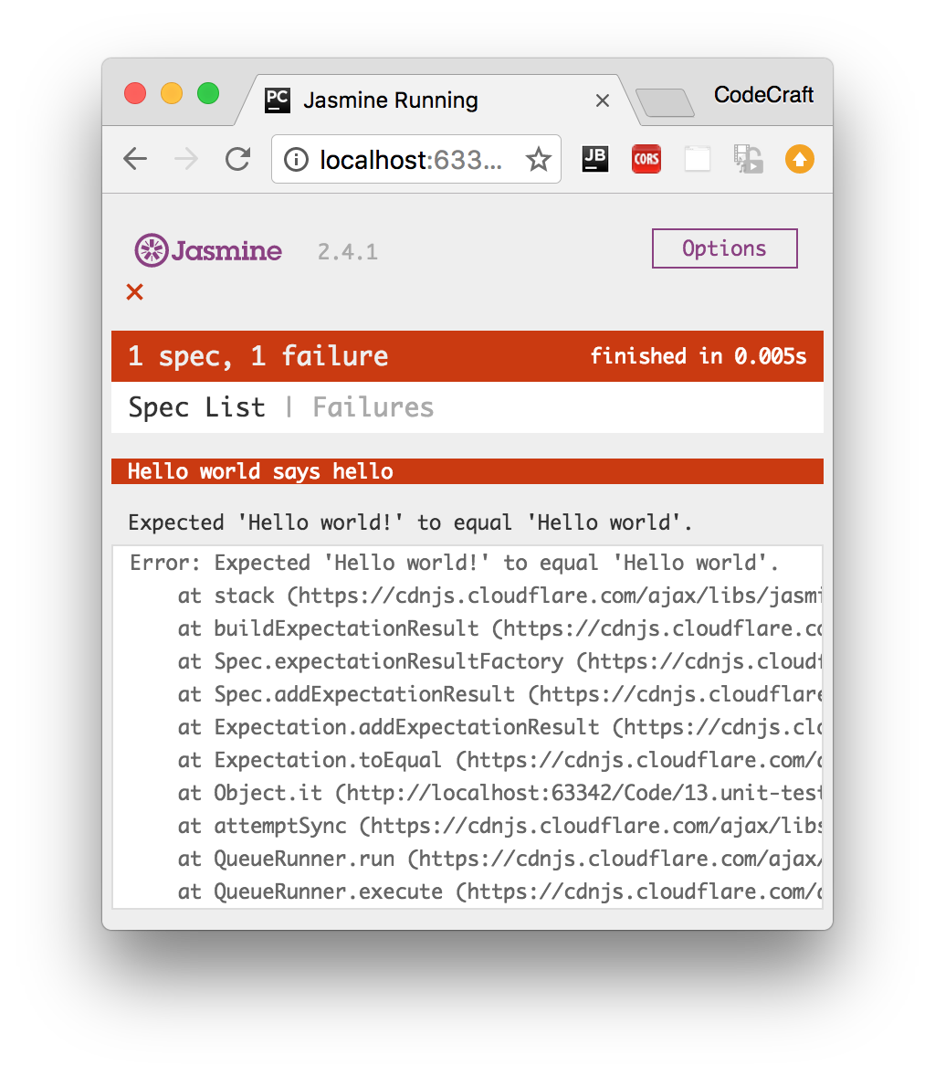

A passing run looks like:

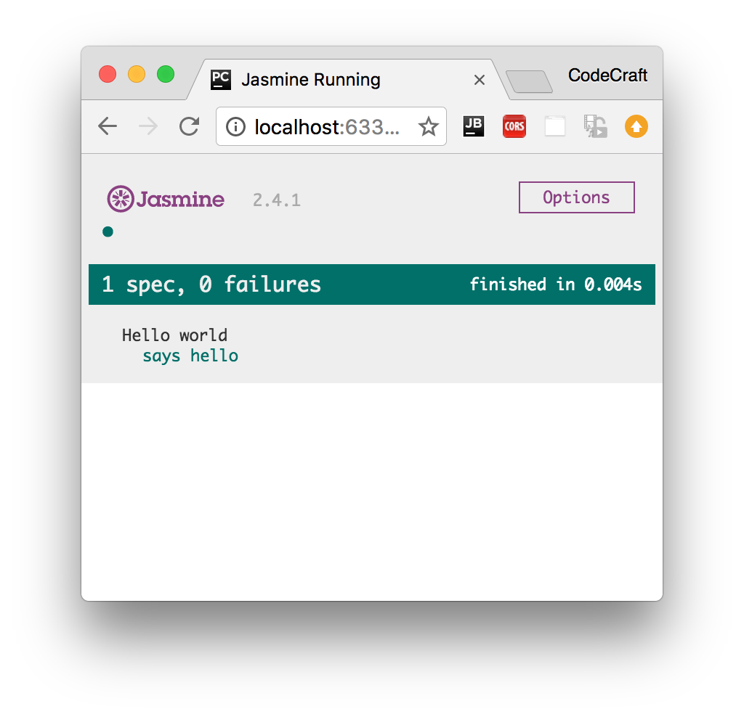

If we wanted to test our code in different browsers we simply load up the HTML file in the browser we want to test in.

If we wanted to debug the code we would use the developer tools available to us in that browser.

**Karma**

Manually running Jasmine tests by refreshing a browser tab repeatedly in different browsers every-time we edit some code can become tiresome.

Karma is a tool which lets us spawn browsers and run jasmine tests inside of them all from the command line. The results of the tests are also displayed on the command line.

Karma can also watch your development files for changes and re-run the tests automatically.

Karma lets us run jasmine tests as part of a development tool chain which requires tests to be runnable and results inspectable via the command line.

It’s not necessary to know the internals of how Karma works. When using the Angular CLI it handles the configuration for us and for the rest of this section we are going to run the tests using only Jasmine.

**Angular CLI**

When creating Angular projects using using the Angular CLI it defaults to creating and running unit tests using Jasmine and Karma.

Whenever we create files using the CLI as well as creating the main code file it also creates simple jasmine spec file named the same as the main code file but ending in .spec.ts, like so:

If we create a Pipe using the CLI like so:

ng generate pipe My

This would create two files:

* my-pipe.ts - This is the main code file where we put the code for the pipe.
* my-pipe.spec.ts - This is the jasmine test suite for the pipe.

The spec file will have some code already bootstrapped, like so:

/* tslint:disable:no-unused-variable */

import { TestBed, async } from '@angular/core/testing';

import { MyPipe } from './my.pipe';

describe('Pipe: My', () => {

it('create an instance', () => {

let pipe = new MyPipe();

expect(pipe).toBeTruthy();

});

})

;



The code that gets bootstrapped depends on the item that we are creating.

To run all the tests in our application we simply type ng test in our project root.

This runs all the tests in our project in Jasmine via Karma.

It watches for changes to our development files, bundles all the developer files together and re-runs the tests automatically.

**Angular Plunker**

When building real Angular applications I recommend sticking with the file and folder structure defined by the Angular CLI as well as using the built-in test runner.

However for this section, to give you an easy way to view and play with the code we are going to use *only* Jasmine and execute tests by refreshing a browser.

This so we can easily share code via a Plunker like we have done for all the other sections in this course.

An Angular Jasmine Plunker looks very similar to a normal Jasmine Plunker appart from a few key differences:

1. We also include the required Angular libraries and some patches for Jasmine so it works better with Angular.

<script src="https://unpkg.com/systemjs@0.19.27/dist/system.src.js"></script>

<script src="https://unpkg.com/reflect-metadata@0.1.3"></script>

<script src="https://unpkg.com/zone.js@0.6.25?main=browser"></script>

<script src="https://unpkg.com/zone.js/dist/long-stack-trace-

zone.js?main=browser"></script>

<script src="https://unpkg.com/zone.js/dist/proxy.js?main=browser"></script>

<script src="https://unpkg.com/zone.js/dist/sync-test.js?main=browser"></script>

<script src="https://unpkg.com/zone.js/dist/jasmine-patch.js?main=browser"></script>

<script src="https://unpkg.com/zone.js/dist/async-test.js?main=browser"></script>

<script src="https://unpkg.com/zone.js/dist/fake-async-test.js?main=browser"></script>

1. We then add the spec files we want to test into a special array called spec_files.

var __spec_files__ = [

'app/auth.service.spec'

]

;

1. We then load a *shim* javascript file which triggers running the test specs once we have finished transpiling and loading the transpiled files in the browser.

<

script src="browser-test-shim.js"></script

>

### Disabled and focused tests

You can disable tests without commenting them our by just pre-pending x to the describe or it functions, like so:

xdescribe('Hello world', () => {

①

xit('says hello', () => {

①

expect(helloWorld())

.toEqual('Hello world!');

});

})

;

① These tests will not be run.

Conversely you can also focus on specific tests by pre-pending with f, like so:

fdescribe('Hello world', () => {

①

fit('says hello', () => {

①

expect(helloWorld())

.toEqual('Hello world!');

});

})

;

① Out of all the tests in all the tests suites and tests specs, these are the only ones that will be run.

**Summary**

Jasmine is a testing framework that supports *Behavior Driven Development*. We write tests in *Test Suites* which are composed of one or more *Test Specs* which themselves are composed of one or more *Test Expectations*.

We can run Jasmine tests in a browser ourselves by setting up and loading a HTML file, but more commonly we use a command line tool called Karma. Karma handles the process of creating HTML files, opening browsers and running tests and returning the results of those tests to the command line.

If you use the Angular CLI to manage projects it automatically creates stub jasmine spec files for you when generating code. It also handles the Karama configuration, transpilation and bundling of your files so all you need to do in order to run your tests is type the command ng test.

For the purposes of this section we will be using a simple browser based Jasmine test runner so we can share the code easily via plunker.

**Listing**

<http://plnkr.co/edit/8ApdkvletoEc4Q0maXSN?p=preview>

*index.html*

<!-- Run application specs in a browser -->

<!DOCTYPE html>

<html>

<head>

<title>Jasmine Running</title>

<meta charset="UTF-8">

<meta name="viewport" content="width=device-width, initial-scale=1">

<link rel="stylesheet"

href="https://cdnjs.cloudflare.com/ajax/libs/jasmine/2.4.1/jasmine.css">

</head>

<body>

<script

src="https://cdnjs.cloudflare.com/ajax/libs/jasmine/2.4.1/jasmine.js"></script>

<script src="https://cdnjs.cloudflare.com/ajax/libs/jasmine/2.4.1/jasmine-

html.js"></script>

<script src="https://cdnjs.cloudflare.com/ajax/libs/jasmine/2.4.1/boot.js"></script>

<script src="main.js"></script>

<script src="test.js"></script>

</body>

</html> *main.js*

function helloWorld() {

return 'Hello world!';

}

*test.js*

describe('Hello world', () => {

let expected = "";

beforeEach(() => {

expected = "Hello world!";

});

afterEach(() => {

expected = "";

});

it('says hello', () => {

expect(helloWorld())

.toEqual(expected);

});

})

;